Test-1

**amount_of_layers=1**

**size_of_layers=256**

**eta=0.01**

**optimization=Adam**

**loss_function=softmax_cross_entropy_with_logits**

**batch_size=100**

**amount_of_epochs=10**

**activation_functions=relu**

**dropout=0.5**

Validation accuracy for epoch 1 is: 0.7833999991416931

Validation loss for epoch 1 is: 1.0461674928665161

Train accuracy for epoch 1 is: 0.772636353969574

Train loss for epoch 1 is: 1.0015031099319458

Validation accuracy for epoch 2 is: 0.8277999758720398

Validation loss for epoch 2 is: 0.715768039226532

Train accuracy for epoch 2 is: 0.8217818140983582

Train loss for epoch 2 is: 0.6602864861488342

Validation accuracy for epoch 3 is: 0.8651999831199646

Validation loss for epoch 3 is: 0.5840829014778137

Train accuracy for epoch 3 is: 0.859036386013031

Train loss for epoch 3 is: 0.5085000991821289

Validation accuracy for epoch 4 is: 0.8777999877929688

Validation loss for epoch 4 is: 0.4757659137248993

Train accuracy for epoch 4 is: 0.8723818063735962

Train loss for epoch 4 is: 0.4324626326560974

Validation accuracy for epoch 5 is: 0.8844000101089478

Validation loss for epoch 5 is: 0.49225762486457825

Train accuracy for epoch 5 is: 0.8914363384246826

Train loss for epoch 5 is: 0.3806600868701935

Validation accuracy for epoch 6 is: 0.9034000039100647

Validation loss for epoch 6 is: 0.40788838267326355

Train accuracy for epoch 6 is: 0.9015818238258362

Train loss for epoch 6 is: 0.34711286425590515

Validation accuracy for epoch 7 is: 0.9065999984741211

Validation loss for epoch 7 is: 0.3853394389152527

Train accuracy for epoch 7 is: 0.9046545624732971

Train loss for epoch 7 is: 0.3300802409648895

Validation accuracy for epoch 8 is: 0.9070000052452087

Validation loss for epoch 8 is: 0.3858671486377716

Train accuracy for epoch 8 is: 0.9115636348724365

Train loss for epoch 8 is: 0.3096488416194916

Validation accuracy for epoch 9 is: 0.9133999943733215

Validation loss for epoch 9 is: 0.3673743009567261

Train accuracy for epoch 9 is: 0.9192181825637817

Train loss for epoch 9 is: 0.2861443758010864

Validation accuracy for epoch 10 is: 0.9161999821662903

Validation loss for epoch 10 is: 0.35218164324760437

Train accuracy for epoch 10 is: 0.92372727394104

Train loss for epoch 10 is: 0.27983665466308594

**Accuracy for Entire test set: 0.9574000239372253**

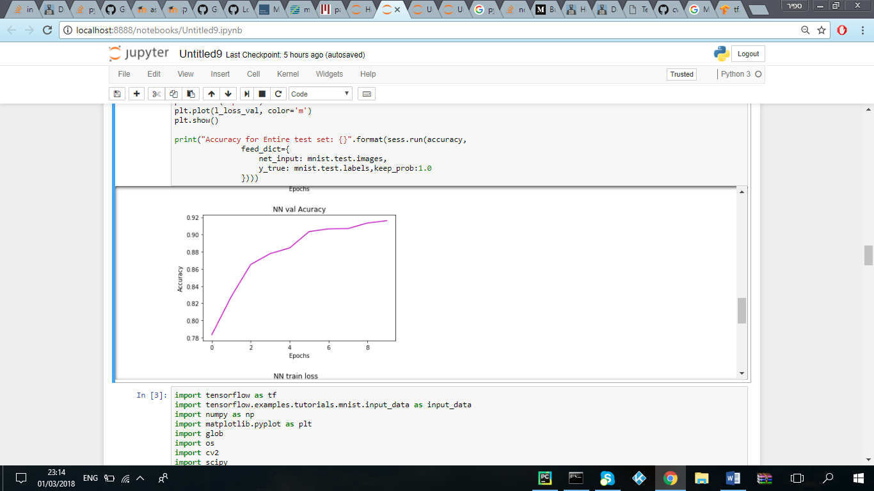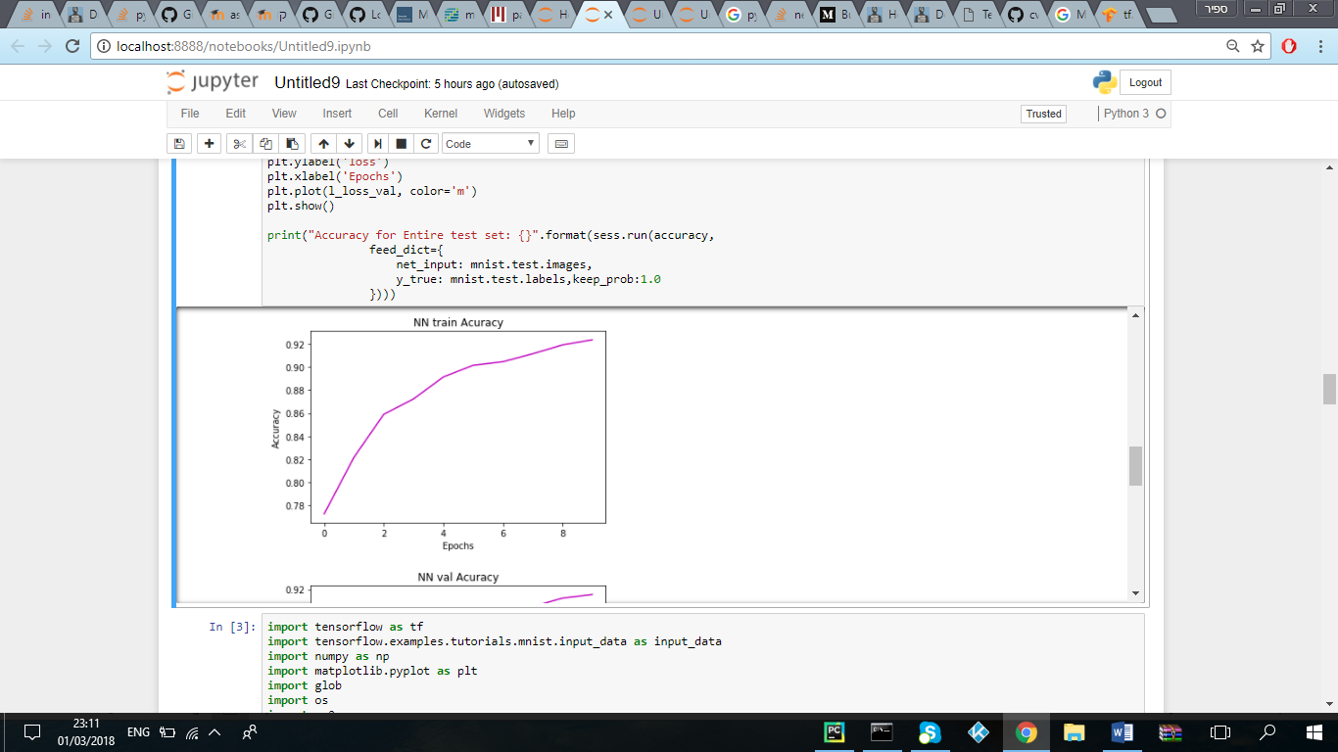

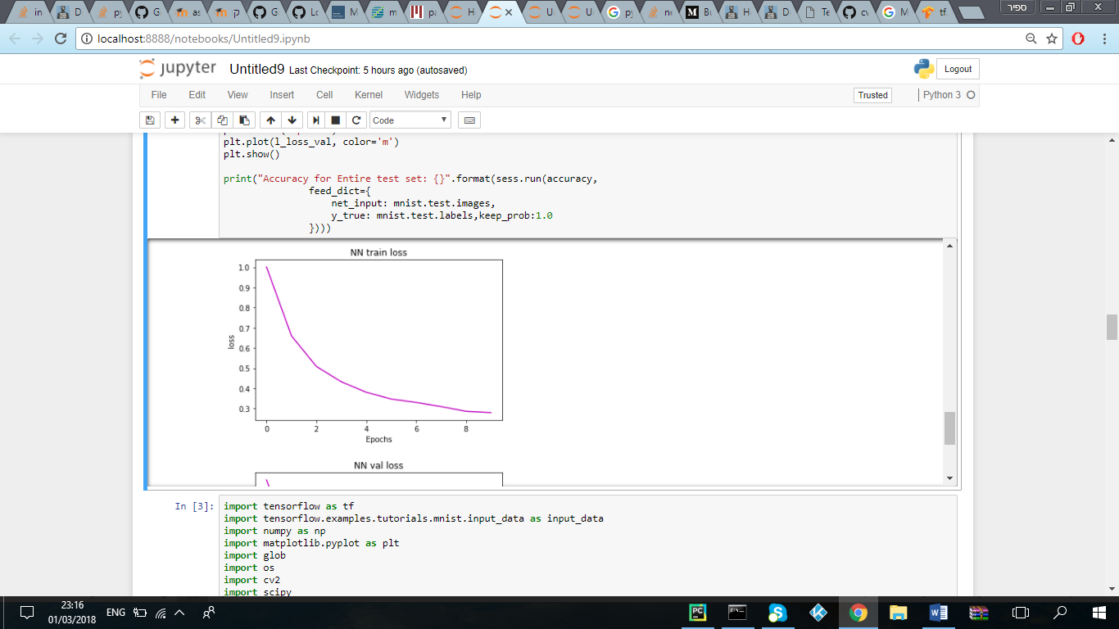

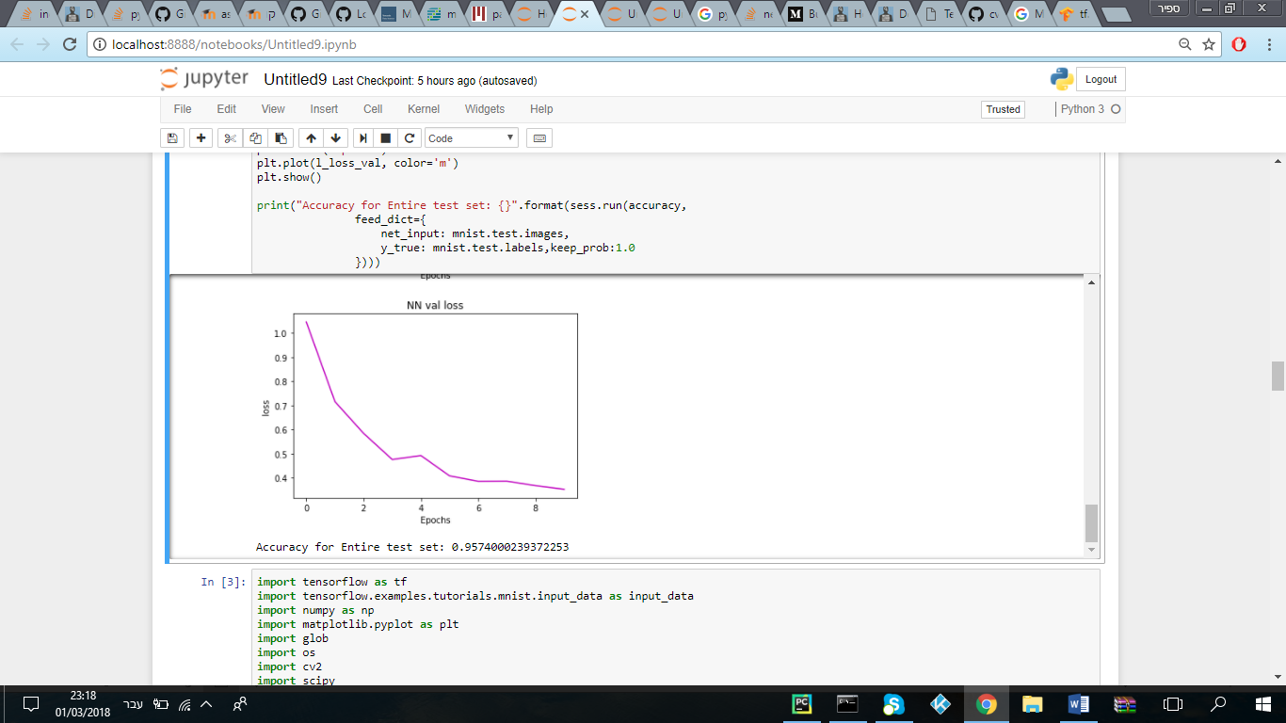

Test-2

**amount_of_layers=2**

**size_of_layers=256,256**

**eta=0.01**

**optimization=GradientDescentOptimizer**

**loss_function=softmax_cross_entropy_with_logits**

**batch_size=100**

**amount_of_epochs=10**

**activation_functions=relu**

**dropout=0.5**

Validation accuracy for epoch 1 is: 0.6815999746322632

Validation loss for epoch 1 is: 13.248309135437012

Train accuracy for epoch 1 is: 0.667127251625061

Train loss for epoch 1 is: 14.280728340148926

Validation accuracy for epoch 2 is: 0.7414000034332275

Validation loss for epoch 2 is: 7.750858783721924

Train accuracy for epoch 2 is: 0.7275636196136475

Train loss for epoch 2 is: 8.413456916809082

Validation accuracy for epoch 3 is: 0.7634000182151794

Validation loss for epoch 3 is: 6.010416030883789

Train accuracy for epoch 3 is: 0.751836359500885

Train loss for epoch 3 is: 5.954264163970947

Validation accuracy for epoch 4 is: 0.7749999761581421

Validation loss for epoch 4 is: 4.658100128173828

Train accuracy for epoch 4 is: 0.762072741985321

Train loss for epoch 4 is: 4.741391658782959

Validation accuracy for epoch 5 is: 0.7889999747276306

Validation loss for epoch 5 is: 3.942547559738159

Train accuracy for epoch 5 is: 0.7727454304695129

Train loss for epoch 5 is: 3.806892156600952

Validation accuracy for epoch 6 is: 0.7882000207901001

Validation loss for epoch 6 is: 3.224090337753296

Train accuracy for epoch 6 is: 0.7737636566162109

Train loss for epoch 6 is: 3.313462972640991

Validation accuracy for epoch 7 is: 0.7807999849319458

Validation loss for epoch 7 is: 2.815614938735962

Train accuracy for epoch 7 is: 0.7767272591590881

Train loss for epoch 7 is: 2.849126100540161

Validation accuracy for epoch 8 is: 0.7904000282287598

Validation loss for epoch 8 is: 2.6240546703338623

Train accuracy for epoch 8 is: 0.781145453453064

Train loss for epoch 8 is: 2.4553775787353516

Validation accuracy for epoch 9 is: 0.7864000201225281

Validation loss for epoch 9 is: 2.2373108863830566

Train accuracy for epoch 9 is: 0.7813272476196289

Train loss for epoch 9 is: 2.2068443298339844

Validation accuracy for epoch 10 is: 0.7919999957084656

Validation loss for epoch 10 is: 2.094592571258545

Train accuracy for epoch 10 is: 0.7837272882461548

Train loss for epoch 10 is: 2.026745557785034

**Accuracy for Entire test set: 0.8902999758720398**

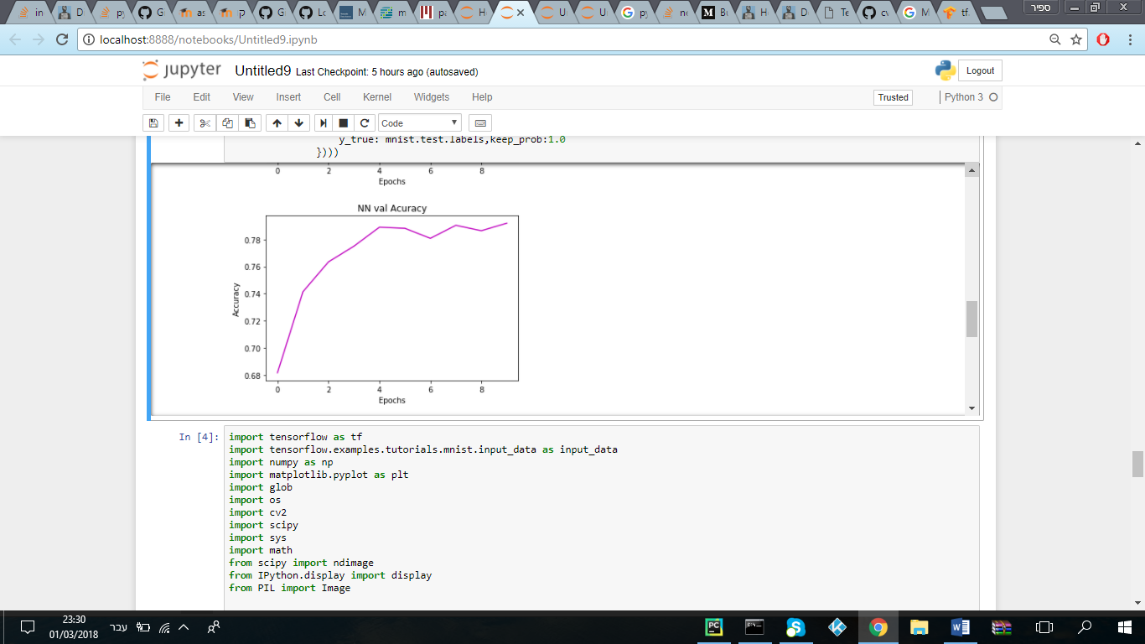

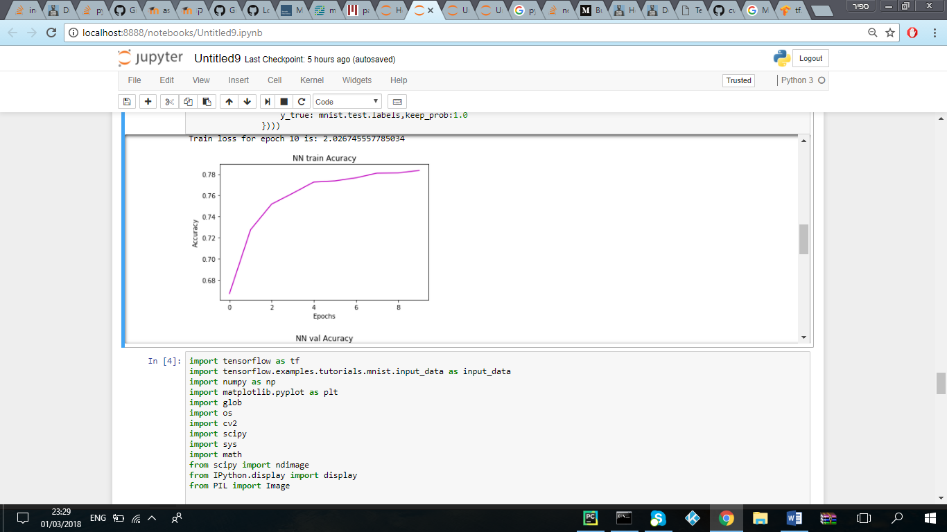

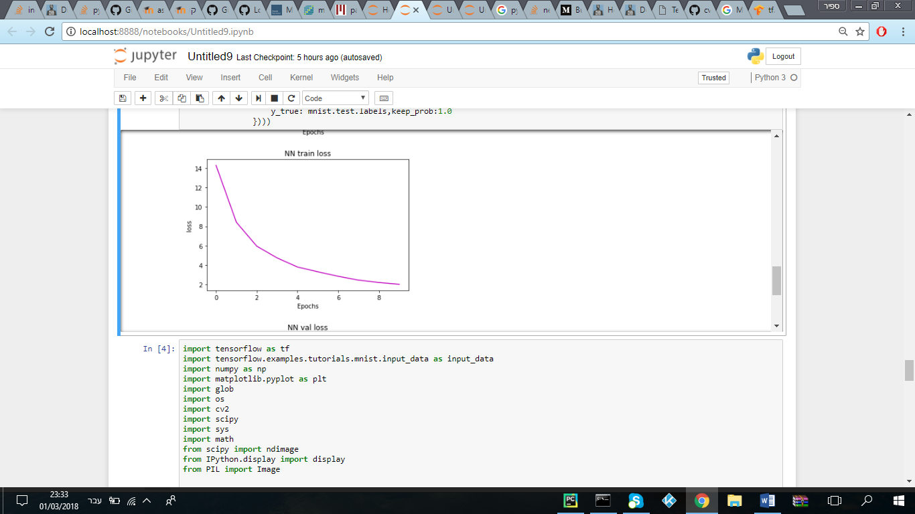

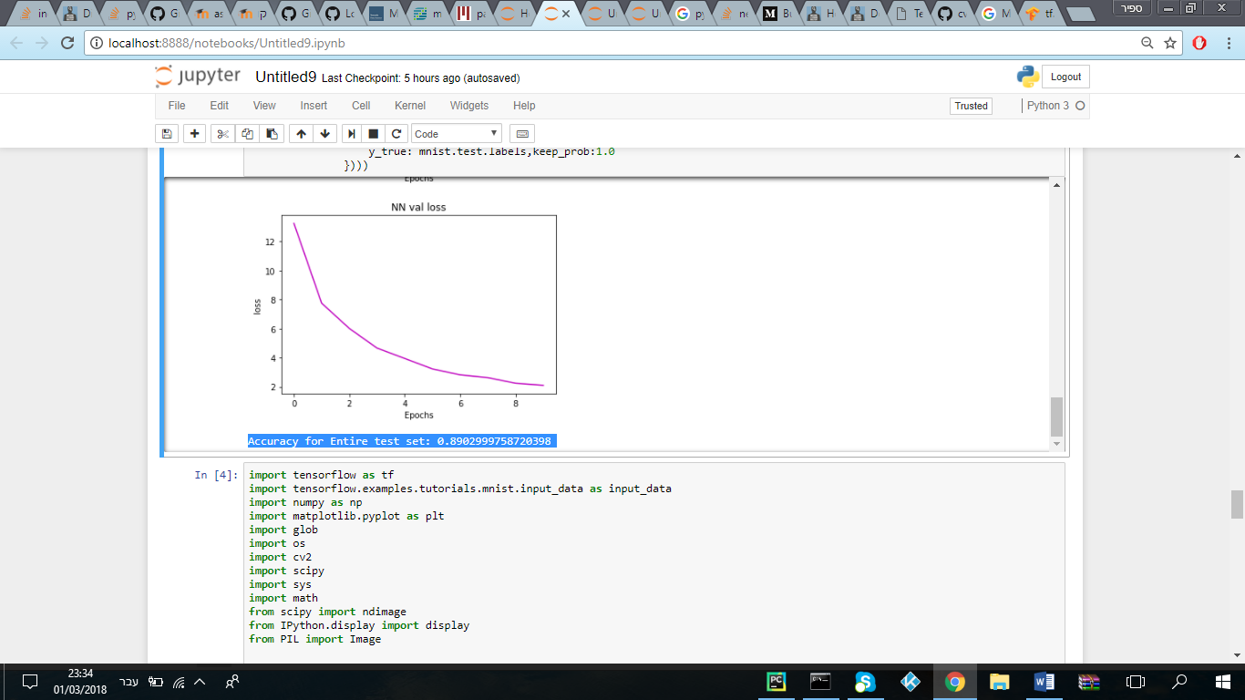

Test-3

**amount_of_layers=2**

**size_of_layers=256,256**

**eta=0.01**

**optimization=Adam**

**loss_function=softmax_cross_entropy_with_logits**

**batch_size=100**

**amount_of_epochs=50**

**activation_functions=relu**

**dropout=0.5**

Validation accuracy for epoch 1 is: 0.7552000284194946

Validation loss for epoch 1 is: 1.051437258720398

Train accuracy for epoch 1 is: 0.7439272999763489

Train loss for epoch 1 is: 1.0543593168258667

Validation accuracy for epoch 2 is: 0.823199987411499

Validation loss for epoch 2 is: 0.6987188458442688

Train accuracy for epoch 2 is: 0.8168545365333557

Train loss for epoch 2 is: 0.6922475099563599

Validation accuracy for epoch 3 is: 0.8496000170707703

Validation loss for epoch 3 is: 0.5930122137069702

Train accuracy for epoch 3 is: 0.8477272987365723

Train loss for epoch 3 is: 0.5272652506828308

Validation accuracy for epoch 4 is: 0.873199999332428

Validation loss for epoch 4 is: 0.47914063930511475

Train accuracy for epoch 4 is: 0.8722181916236877

Train loss for epoch 4 is: 0.44683921337127686

Validation accuracy for epoch 5 is: 0.8920000195503235

Validation loss for epoch 5 is: 0.43980860710144043

Train accuracy for epoch 5 is: 0.8820363879203796

Train loss for epoch 5 is: 0.39706262946128845

Validation accuracy for epoch 6 is: 0.9035999774932861

Validation loss for epoch 6 is: 0.4129573106765747

Train accuracy for epoch 6 is: 0.8983272910118103

Train loss for epoch 6 is: 0.3471555709838867

Validation accuracy for epoch 7 is: 0.900600016117096

Validation loss for epoch 7 is: 0.38643017411231995

Train accuracy for epoch 7 is: 0.9043818116188049

Train loss for epoch 7 is: 0.3392888903617859

Validation accuracy for epoch 8 is: 0.9049999713897705

Validation loss for epoch 8 is: 0.3953646421432495

Train accuracy for epoch 8 is: 0.9083454608917236

Train loss for epoch 8 is: 0.325269877910614

Validation accuracy for epoch 9 is: 0.9147999882698059

Validation loss for epoch 9 is: 0.34341856837272644

Train accuracy for epoch 9 is: 0.9138727188110352

Train loss for epoch 9 is: 0.29275867342948914

Validation accuracy for epoch 10 is: 0.9089999794960022

Validation loss for epoch 10 is: 0.35575786232948303

Train accuracy for epoch 10 is: 0.9126363396644592

Train loss for epoch 10 is: 0.29177701473236084

Validation accuracy for epoch 11 is: 0.9125999808311462

Validation loss for epoch 11 is: 0.3675598204135895

Train accuracy for epoch 11 is: 0.9172363877296448

Train loss for epoch 11 is: 0.29908838868141174

Validation accuracy for epoch 12 is: 0.9156000018119812

Validation loss for epoch 12 is: 0.32916781306266785

Train accuracy for epoch 12 is: 0.9223091006278992

Train loss for epoch 12 is: 0.2763427793979645

Validation accuracy for epoch 13 is: 0.9228000044822693

Validation loss for epoch 13 is: 0.32636669278144836

Train accuracy for epoch 13 is: 0.9294363856315613

Train loss for epoch 13 is: 0.2616346478462219

Validation accuracy for epoch 14 is: 0.9218000173568726

Validation loss for epoch 14 is: 0.33237409591674805

Train accuracy for epoch 14 is: 0.9264181852340698

Train loss for epoch 14 is: 0.26083317399024963

Validation accuracy for epoch 15 is: 0.9261999726295471

Validation loss for epoch 15 is: 0.3104301691055298

Train accuracy for epoch 15 is: 0.9318727254867554

Train loss for epoch 15 is: 0.2376452088356018

Validation accuracy for epoch 16 is: 0.9308000206947327

Validation loss for epoch 16 is: 0.31104809045791626

Train accuracy for epoch 16 is: 0.93425452709198

Train loss for epoch 16 is: 0.24305836856365204

Validation accuracy for epoch 17 is: 0.9291999936103821

Validation loss for epoch 17 is: 0.3054438829421997

Train accuracy for epoch 17 is: 0.9345454573631287

Train loss for epoch 17 is: 0.23090246319770813

Validation accuracy for epoch 18 is: 0.9326000213623047

Validation loss for epoch 18 is: 0.3119608759880066

Train accuracy for epoch 18 is: 0.9367454648017883

Train loss for epoch 18 is: 0.23059861361980438

Validation accuracy for epoch 19 is: 0.9354000091552734

Validation loss for epoch 19 is: 0.32919469475746155

Train accuracy for epoch 19 is: 0.9360363483428955

Train loss for epoch 19 is: 0.2323700487613678

Validation accuracy for epoch 20 is: 0.9273999929428101

Validation loss for epoch 20 is: 0.33832135796546936

Train accuracy for epoch 20 is: 0.9357272982597351

Train loss for epoch 20 is: 0.23462438583374023

Validation accuracy for epoch 21 is: 0.9359999895095825

Validation loss for epoch 21 is: 0.3388199806213379

Train accuracy for epoch 21 is: 0.937818169593811

Train loss for epoch 21 is: 0.23987500369548798

Validation accuracy for epoch 22 is: 0.9368000030517578

Validation loss for epoch 22 is: 0.30652791261672974

Train accuracy for epoch 22 is: 0.9423817992210388

Train loss for epoch 22 is: 0.21555426716804504

Validation accuracy for epoch 23 is: 0.9301999807357788

Validation loss for epoch 23 is: 0.3490917682647705

Train accuracy for epoch 23 is: 0.9401090741157532

Train loss for epoch 23 is: 0.22346366941928864

Validation accuracy for epoch 24 is: 0.9426000118255615

Validation loss for epoch 24 is: 0.28234291076660156

Train accuracy for epoch 24 is: 0.944454550743103

Train loss for epoch 24 is: 0.21420498192310333

Validation accuracy for epoch 25 is: 0.9318000078201294

Validation loss for epoch 25 is: 0.31861612200737

Train accuracy for epoch 25 is: 0.9424545168876648

Train loss for epoch 25 is: 0.22414618730545044

Validation accuracy for epoch 26 is: 0.9368000030517578

Validation loss for epoch 26 is: 0.30478519201278687

Train accuracy for epoch 26 is: 0.9421454668045044

Train loss for epoch 26 is: 0.20321999490261078

Validation accuracy for epoch 27 is: 0.9380000233650208

Validation loss for epoch 27 is: 0.2818596065044403

Train accuracy for epoch 27 is: 0.9469636082649231

Train loss for epoch 27 is: 0.1892445683479309

Validation accuracy for epoch 28 is: 0.942799985408783

Validation loss for epoch 28 is: 0.32774174213409424

Train accuracy for epoch 28 is: 0.9473817944526672

Train loss for epoch 28 is: 0.18704970180988312

Validation accuracy for epoch 29 is: 0.9399999976158142

Validation loss for epoch 29 is: 0.31512388586997986

Train accuracy for epoch 29 is: 0.9463818073272705

Train loss for epoch 29 is: 0.19754840433597565

Validation accuracy for epoch 30 is: 0.9368000030517578

Validation loss for epoch 30 is: 0.3426322340965271

Train accuracy for epoch 30 is: 0.9450363516807556

Train loss for epoch 30 is: 0.2046585977077484

Validation accuracy for epoch 31 is: 0.9368000030517578

Validation loss for epoch 31 is: 0.32962632179260254

Train accuracy for epoch 31 is: 0.9440909028053284

Train loss for epoch 31 is: 0.20741726458072662

Validation accuracy for epoch 32 is: 0.9383999705314636

Validation loss for epoch 32 is: 0.3489943742752075

Train accuracy for epoch 32 is: 0.9483454823493958

Train loss for epoch 32 is: 0.19910845160484314

Validation accuracy for epoch 33 is: 0.9398000240325928

Validation loss for epoch 33 is: 0.3358055055141449

Train accuracy for epoch 33 is: 0.9477999806404114

Train loss for epoch 33 is: 0.19961297512054443

Validation accuracy for epoch 34 is: 0.9412000179290771

Validation loss for epoch 34 is: 0.3414097726345062

Train accuracy for epoch 34 is: 0.9505090713500977

Train loss for epoch 34 is: 0.1887146234512329

Validation accuracy for epoch 35 is: 0.9340000152587891

Validation loss for epoch 35 is: 0.3777696490287781

Train accuracy for epoch 35 is: 0.9448727369308472

Train loss for epoch 35 is: 0.20662687718868256

Validation accuracy for epoch 36 is: 0.9412000179290771

Validation loss for epoch 36 is: 0.33390599489212036

Train accuracy for epoch 36 is: 0.9509999752044678

Train loss for epoch 36 is: 0.18889914453029633

Validation accuracy for epoch 37 is: 0.9394000172615051

Validation loss for epoch 37 is: 0.3600403070449829

Train accuracy for epoch 37 is: 0.9522908926010132

Train loss for epoch 37 is: 0.18186227977275848

Validation accuracy for epoch 38 is: 0.9398000240325928

Validation loss for epoch 38 is: 0.3538612723350525

Train accuracy for epoch 38 is: 0.9503090977668762

Train loss for epoch 38 is: 0.19437086582183838

Validation accuracy for epoch 39 is: 0.9359999895095825

Validation loss for epoch 39 is: 0.33588749170303345

Train accuracy for epoch 39 is: 0.9506545662879944

Train loss for epoch 39 is: 0.2118014544248581

Validation accuracy for epoch 40 is: 0.9434000253677368

Validation loss for epoch 40 is: 0.3416760563850403

Train accuracy for epoch 40 is: 0.9521454572677612

Train loss for epoch 40 is: 0.17154639959335327

Validation accuracy for epoch 41 is: 0.9395999908447266

Validation loss for epoch 41 is: 0.35723963379859924

Train accuracy for epoch 41 is: 0.9555636644363403

Train loss for epoch 41 is: 0.17671924829483032

Validation accuracy for epoch 42 is: 0.9458000063896179

Validation loss for epoch 42 is: 0.3349147439002991

Train accuracy for epoch 42 is: 0.9509272575378418

Train loss for epoch 42 is: 0.18810488283634186

Validation accuracy for epoch 43 is: 0.9390000104904175

Validation loss for epoch 43 is: 0.3310149312019348

Train accuracy for epoch 43 is: 0.9494545459747314

Train loss for epoch 43 is: 0.1887669712305069

Validation accuracy for epoch 44 is: 0.9440000057220459

Validation loss for epoch 44 is: 0.35853809118270874

Train accuracy for epoch 44 is: 0.9553818106651306

Train loss for epoch 44 is: 0.18092066049575806

Validation accuracy for epoch 45 is: 0.9449999928474426

Validation loss for epoch 45 is: 0.367432564496994

Train accuracy for epoch 45 is: 0.9527999758720398

Train loss for epoch 45 is: 0.17985469102859497

Validation accuracy for epoch 46 is: 0.9409999847412109

Validation loss for epoch 46 is: 0.3807617127895355

Train accuracy for epoch 46 is: 0.9517272710800171

Train loss for epoch 46 is: 0.19943267107009888

Validation accuracy for epoch 47 is: 0.942799985408783

Validation loss for epoch 47 is: 0.37392181158065796

Train accuracy for epoch 47 is: 0.9534000158309937

Train loss for epoch 47 is: 0.18077006936073303

Validation accuracy for epoch 48 is: 0.9498000144958496

Validation loss for epoch 48 is: 0.3482619524002075

Train accuracy for epoch 48 is: 0.9583272933959961

Train loss for epoch 48 is: 0.1525661200284958

Validation accuracy for epoch 49 is: 0.9470000267028809

Validation loss for epoch 49 is: 0.34998413920402527

Train accuracy for epoch 49 is: 0.9559272527694702

Train loss for epoch 49 is: 0.17479050159454346

Validation accuracy for epoch 50 is: 0.944599986076355

Validation loss for epoch 50 is: 0.383202463388443

Train accuracy for epoch 50 is: 0.9532363414764404

Train loss for epoch 50 is: 0.18237417936325073

**Accuracy for Entire test set: 0.9700000286102295**

